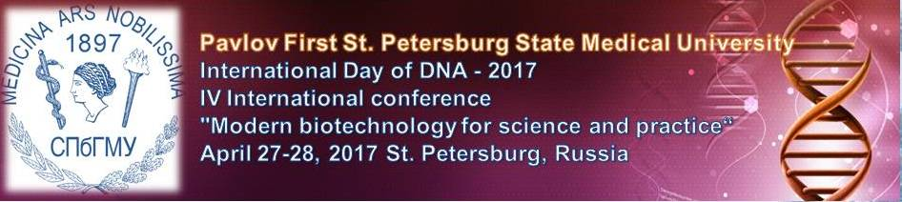

First announcement
Dear Colleagues and Friends,
Scientific and Methodological Center for the Russian Health Ministry on Molecular Medicine, Pavlov First St. Petersburg State Medical University, the Federation of laboratory medicine and "Medical information-analytical centre" are glad to announce that the IV International conference "Modern biotechnology for science and practice" will be held again from April 27-28, 2016, in St. Petersburg, Russia. It will focus on the topic: New biotechnology approaches in biology and medicine.

The scientific committee of the International Day of DNA - 2016 welcomes abstracts according a topic:
- Modern biotechnology in oncology,
- Modern biotechnology in immunology,
- Modern biotechnology in hematology,
- Modern biotechnology in therapy,
- Modern biotechnology in immunotherapy,
- Modern biotechnology in gene therapy,
- Modern biotechnology in targeted therapy,
- Modern biotechnology in fundamental investigations,
- Research and Development,
- Other
The submission for abstracts is available for all authors via mail of scientific committee: dna_day_2017@mail.ru. The submission deadline April 3, 2017 (see below).
For registration please fill the Application Form (see below) and send it by e-mail to the organizing committee dna_day_2016@mail.ru
Please forward this newsletter to all interested colleagues
Sincerely yours
The Local Organizing Committee
Contact person: Zarayskiy Mikhail
mail: dna_day_2016@mail.ru

We will be glad to see you among the participants of the symposium.

ABSTRACT RULES

Please note that abstracts are not edited, but estimated by Review Commission after the deadline for receiving papers.
Submission of abstracts will be accepted until April 3, 2017
Publication of works is free.

Subject abstracts must match the name of the conference:
"Modern biotechnology for science and practice"

Rules for writing papers
• Abstracts submitted for publication in Russian or English.
• Abstracts should be typed in Word and carefully edited, as in the future will not be edited.
• Font - Times New Roman, font size 12, 1.5 line spacing. Margins: left - 30 mm, right - 15 mm, top - 25 mm, bottom - 25 mm. Maximum total - no more pages (about 2000 characters without spaces).
• Abstracts may comprise a single table. Figures do not include.
• The title should be in capital letters.
• Names and initials of authors are printed in uppercase and lowercase letters.
• The next line specifies the name of the institution, city and country. (Sample below) :

Using polymerase chain reaction (PCR) to search for mutations in the coding region of DNA.
Ivanov I.I., Petrov P.P.
St-Petersburg Pavlov State Medical University MZRF, St. Petersburg

Introduction. Start of text .....

• Works must contain specific factual scientific nature obtained by the author and include the following sections: introduction, purpose and objectives, materials and methods, main results , the conclusion / findings.
• Information in the writings of advertising is not permitted.
• Prepared files with the works sent by e-mail to the organizing committee dna_day_2017@mail.ru
• One file should contain no more than one job. Submit no more than 3 works by one author. The maximum amount of a single file is not more than 2 MB.

APPLICATION FORM
to participate in the
International Day of DNA-2017.
Name
Organization
Position
Country
City
Work address
Postcode
Contact phone
e-mail

Form of participation:

⃝ | Participation in the international conference "Modern biotechnology for science and practice" with the publication of abstracts.
⃝ | Participation in the international conference "Modern biotechnology for science and practice" without publication of abstracts.
⃝ | Only publication of abstracts

Please send me the abstracts at my email address: ______________________.

